caBIG ® Clinical Connector

Software Architecture Document

Version No: 2.2
Last Modified: 10/2/2010

Author : Patrick Conrad, Amit Srivastava
Team : caBIG® Clinical Connector

Client : National Cancer Institute - Center for Bioinformatics,
National Institutes of Health,
US Department of Health and Human Services

Document History

Document Location
The most current version of this document is located in Subversion.

Revision History
Version Number | Revision Date | Author | Summary of Changes
1.0 | 05/05/2008 | Patrick Conrad | Initial Draft
2.1 | 04/07/2010 | Patrick Conrad | Brought document up to v2.1 level
2.1 | 05/4/2010 | Patrick Conrad | Added Technical overview section with design and class diagrams
2.2 | 10/2/2010 | Patrick Conrad | Added changes related to v2.2

Review
Name | Team/Role | Version | Date Reviewed | Reviewer Comments

TABLE OF CONTENTS
caBIG ® Clinical Connector 1
Software Architecture Document 1
Version No: 2.2 1
Document History 2
Document Location 2
Revision History 2
Review 2
1 Introduction 6
1.1 Chapter Organization and Content 6
1.2 Overview of the Guide 6
1.3 Organization of the Guide 6
1.4 Intended Audience for the Guide 7
1.5 Scope of the Guide 7
1.6 Document Text Conventions 7
1.7 Related documents 8
2 Overview of the Software 9
2.1 Chapter Organization and Content 9
2.2 Software Overview 9
2.2.1 Project Background 9
2.2.2 System Overview 9
2.2.3 Features of the caBIG® Clinical Connector 10
2.3 System Requirements 10
3 caBIG® Clinical Connector Installation 12
3.1 Chapter Organization and Content 12
3.2 Installation Prerequisites 12
3.3 Installation Instructions 12
3.4 Installation Verification 12
4 caBIG® Clinical Connector Requirements 14
4.1 Chapter Organization and Content 14
4.2 Summary of caBIG® Clinical Connector Requirements 14
5 caBIG® Clinical Connector Architecture 15
5.1 Chapter Organization and Content 15
5.2 System Architecture Overview 15
5.3 Architectural Design 16
5.4 Technology Stack 17
5.5 Deployment strategy 17
6 caBIG® Clinical Connector Technical Overview 19
6.1 Chapter Organization and Content 19
6.2 Technical Design 19
6.3 Class Diagram 21
Appendix A References 22
Technical Manuals and Articles 22
caBIG® Material 22
caCORE Material 22
Appendix B Glossary 23
List of Figures
Figure 1 caBIG® Clinical Connector 2.2 High Level Data Flow 15
Figure 2 caBIG® Clinical Connector n-tier architecture Diagram 16
Figure 3 Deployment Strategy Diagram 18
Figure 4 Overall flow of services 19
Figure 5 Class Diagram 21

List of Tables
Table 1 - Main Contents of the caBIG® Clinical Connector Technical Architecture Document 6
Table 2 - Document Conventions 6
Table 3 - Key Roles in the caBIG® Clinical Connector Project 9
Table 4 - High Level Summary of Requirements 9

Introduction
The caBIG® Clinical Connector provides grid services as an interface to operations that support the clinical trials workspace of C3D.
This Software Architecture Guide provides the software architecture and high level design for the caBIG® Clinical Connector. This document provides recommendations and guidelines to the development team to develop a detailed design for the system. It emphasizes the architecturally significant parts of the design model.

Chapter Organization and Content
The purpose of this chapter is to provide a high level overview of the caBIG® Clinical Connector, its components, and the overall content of this guide.
Topics in this chapter include:
- Overview of the Guide
- Organization of the GuideIntended Audience for the Guide
- Scope of the Guide
- Document Text ConventionsRelated documents

Overview of the Guide
This guide introduces the technical and architectural aspects of the caBIG® Clinical Connector Version 2.1. It provides an overview of the architecture, describes the components and their use cases, identifies the technology stack, and provides some technical reference.

Organization of the Guide
This table provides a summary of the focus of each chapter.
Table 1 - Main Contents of the caBIG® Clinical Connector Technical Architecture Document
Chapters  Architecture Guide | Chapter Contents
Chapter 1 | Introduction
Chapter 2 | Overview of the Software
Chapter 3 | caBIG® Clinical Connector Installation
Chapter 4 | caBIG® Clinical Connector Requirements
Chapter 5 | caBIG® Clinical Connector Architecture
Chapter 6 | caBIG® Clinical Connector Architecture
Appendix A | References
Appendix B | Glossary
Index | Index

Intended Audience for the Guide
The intended audience for this document includes developers and architects interested in obtaining an overview of the architecture and high level design for the caBIG® Clinical Connector.

Scope of the Guide
The scope of this document is limited to the requirements as identified in caBIG® Clinical Connector version 2.2. For additional project and requirement-specific information, please refer to the following documents:
- caBIG® Clinical Connector Use Case Documents
The latest versions of these documents can be found in:
https://ncisvn.nci.nih.gov/svn/c3dtools/trunk/clinicalConnector/docs/Use%20Cases/

Document Text Conventions
The following table shows the various typefaces to differentiate between regular text and menu commands, keyboard keys, and text that you type. This illustrates how conventions are represented in this guide.
Table 2 - Document Conventions
Convention | Description | Example
Bold & Capitalized Command  Capitalized command > Capitalized command | Indicates a Menu command  Indicates Sequential Menu commands | Admin > Refresh
text in small caps | Keyboard key that you press | Press enter
text in small caps + text in small caps | Keyboard keys that you press simultaneously | Press shift + ctrl and then release both.
Special typestyle | Used for filenames, directory names, commands, file listings, source code examples and anything that would appear in a Java program, such as methods, variables, and classes. | URL_definition ::= url_string
Boldface type | Options that you select in dialog boxes or drop-down menus. Buttons or icons that you click. | In the Open dialog box, select the file and click the Open button.
Italics | Used to reference other documents, sections, figures, and tables. | caCORE Software Development Kit 1.0 Programmer’s Guide
Italic boldface type | Text that you type | In the New Subset text box, enter Proprietary Proteins.
Note: | Highlights a concept of particular interest | Note: This concept is used throughout the installation manual.
Warning! | Highlights information of which you should be particularly aware. | Warning! Deleting an object will permanently delete it from the database.
{} | Curly brackets are used for replaceable items. | Replace {root directory} with its proper value such as c:\cabio

Related documents
For additional project information, please refer to the following documents:
- caBIG® Clinical Connector Installation Guide
- caBIG® Clinical Connector Administration Guide
- caBIG® Clinical Connector Use Cases.
The latest versions of these documents can be found in:
https://ncisvn.nci.nih.gov/svn/c3dtools/trunk/clinicalConnector/docs

Overview of the Software

Chapter Organization and Content
Topics in this chapter include:
- Project Background
- System Overview
- Features of the caBIG® Clinical Connector
- System Requirements

Software Overview

Project Background
The caBIG® Clinical Connector was originally designed as a proof of concept, showing that a Java based service could be created that would interact with the C3D CTMS environment. The early proof of concept bypassed the API functionality provided with C3D and worked directly with the underlying objects of the database. This iteration of the service was reworked so that the API functions would be used instead.
Expanding beyond a proof of concept, the caBIG® Clinical Connector was brought into the caBIG® Clinical Trials Suite of applications to allow for interaction with the C3D Clinical Trials Management System. In this role, the caBIG® Clinical Connector is a Grid Service and does not have a user interface of its own. It relies on the other applications of the caBIG® Clinical Trials Suite to invoke it and provides output and responses through normal Java messaging services.
This project focuses on the development of an open-source, caBIG® compatible solution. The resulting solution is intended to be caBIG® Silver-level compatible.

System Overview
The goal of this project is to build a grid service for the interaction between Suite applications and the C3D CTMS. All work performed for this project must be done in compliance with the caBIG® principles of open source, open development, open access, and federation. Software that is used and/or developed in the context of this project must be caBIG® compatible at the silver level.
The key roles in the project are defined in the following table:
Table 3 - Key Roles in the caBIG® Clinical Connector Project
Role | Name | Comments
Project Sponsor | caBIG®
Reviewer | caBIG® Architecture Workspace | Will review and provide guidance of architecture artifacts
User | NCICB | Responsible for hosting the service
Developer | Ekagra Software Technologies | Development team

Features of the caBIG® Clinical Connector
Key features of the caBIG® Clinical Connector solution includes the following:
- Leverages current Oracle Clinical Data Capture APIs for patient data loading service.
- The caBIG® Clinical Connector installation is compliant with the NCI Build Deployment Automation (BDA)
- Provides installation scripts to install all caBIG® Clinical Connector database objects / utilities.
- Integration smoke tests to verify installation.
- Supports caGrid user authentication and authorization.
- Supports the caBIG Suite Unified Common Security Module (CSM).

System Requirements
The following table provides a very high-level summary of the requirements of the caBIG® Clinical Connector:
Table 4 - High Level Summary of Requirements
Requirement ID | Requirement Description
1.0 | The caBIG® Clinical Connector must be built using open source technologies.
2.0 | The caBIG® Clinical Connector must be able to enroll a patient on a C3D Study and populate the demographic data points of C3D.
3.0 | The caBIG® Clinical Connector must be able to locate and populate the patient id and NCI Institution Code data points within the study for the patient being loaded.
4.0 | The caBIG® Clinical Connector must be able to leverage the Oracle Clinical Data Capture APIs (DCAPI) when populating data points within a study.
5.0 | The caBIG® Clinical Connector must be able to accept laboratory test results and load them to C3D.
6.0 | The caBIG® Clinical Connector must be able to alert users when accepted laboratory test results cannot be loaded into C3D.
7.0 | The caBIG® Clinical Connector must be able to return all data point definitions of a study based upon study identifier.
8.0 | The caBIG® Clinical Connector must be able to return all data points of a study based upon study identifier and common data element identifier.
9.0 | The caBIG® Clinical Connector must authenticate service requests.
10.0 | The caBIG® Clinical Connector must provide user level authorization for each service.
11.0 | The caBIG® Clinical Connector build and installation scripts must comply with the NCI CBIIT Build and Deployment Automation (BDA) framework.

caBIG® Clinical Connector Installation

Chapter Organization and Content
Topics in this chapter include:
- Installation Prerequisites
- Installation Instructions
- Installation Verification

Installation Prerequisites
Due to the nature of the caBIG® Clinical Connector and its relationship to C3D (Oracle Clinical), there are several unique prerequisites. These prerequisites are detailed in Chapter 12 of the caBIG® Clinical Trials Suite 2.2 Installation Guide, which can be found here:
https://wiki.nci.nih.gov/display/Suite/12+-+Installing+Software+Prerequisites+for+Clinical+Connector+v2.2

Installation Instructions
caBIG® Clinical Connector complies with the NCI CBIIT Build and Deployment Automation (BDA) framework. The installation of the connector can be found in Chapter 13 of the caBIG® Clinical Trials Suite 2.1 Installation Guide, which can be found here:
https://wiki.nci.nih.gov/display/Suite/13+-+Installing+Clinical+Connector+v2.2

Installation Verification
caBIG® Clinical Connector comes with a series of smoke tests that can be used to verify the installation. These smoke tests are packaged into a simple JavaServer Page GUI called happy.jsp.
The following Test Scenarios have been provided for by the happy.jsp:
Test | Link on the Happy.JSP
Register Subject | testRegisterSubject
Load Labs | testLoadLabsService
Validate Study | testIsValidStudy
Get Study CDEs | testGetStudyCDEs
Get Study CDE Data | testGetStudyCDEsData
Database Connectivity | testDBConnectivity

Each of the test links provides a means for changing the various input variables prior to submission. The GUI will also display a container showing the XML used during the test. And finally, for tests that produce output, another container will be provided that provides the actual returned output of the service. Test result status is also provided.
The happy.jsp can be executed from the Clinical Connector Windows tier by entering the following URL into the Internet Browser:
https://localhost:58445/clinicalConnector/happy.jsp

caBIG® Clinical Connector Requirements

Chapter Organization and Content
This chapter includes:
- Summary of caBIG® Clinical Connector Requirements

Summary of caBIG® Clinical Connector Requirements
The high level requirements for caBIG® Clinical Connector are listed below:
- Provide Cagrid service that allows patients to be enrolled on to C3D Studies
- Enroll Patient service must use standard Oracle Clinical Data Capture APIs
- Provide Cagrid service that allows Lab Test Results for Patients to be loaded to a C3D Study
- Provide Cagrid service that allows for the discovery of all Common Data Element identifiers (CDE Id) for a C3D Study.
- Provide Cagrid service that allows for the extraction of patient data from a C3D Study, by Common Data Element (CDE Id)
- Ensure access to grid services is only to Authenticated caGrid users
- Ensure access to grid services is to authorized caGrid users using caBIG Suite Unified Security
- Grid Services must comply with NCIs Build Deployment Automation methodology

caBIG® Clinical Connector Architecture

Chapter Organization and Content
Topics in this chapter include:
- System Architecture Overview
- Architectural Design

System Architecture Overview
- caBIG® Clinical Connector provides the ability to interact with the C3D system by the means of grid services. These services allow external systems to both feed data to and consume data from the C3D System.
- Figure 1 shows a high-level view of the two service types, Inbound and Outbound. The Inbound Services provide a means by which data is passed into the C3D System. The Outbound Services provide a means by which data can be retrieved from the C3D System.
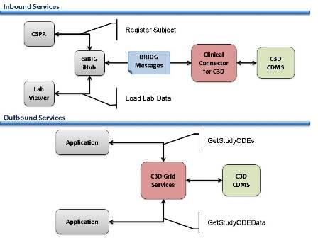
Figure 1 caBIG® Clinical Connector 2.2 High Level Data Flow

Architectural Design
The caBIG® Clinical Connector utilizes caGrid and BRIDG to expose its services. Internally, it is built in tiers with communication happening between the adjacent tiers. The n-tier architecture makes the system flexible and more manageable, where any tier of the system could be replaced with another identical tier.
The following diagram depicts the n-tier architecture used by caBIG® Clinical Connector:

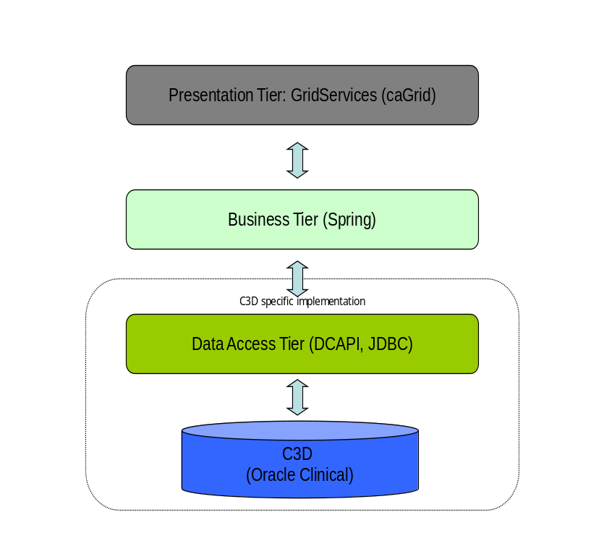
Figure 2 caBIG® Clinical Connector n-tier architecture Diagram

Domain: The domain model of caBIG® Clinical Connector grid-service is based on BRIDG2.0. The connector internally uses a different and smaller model with an adapter to convert between the two. The presence of the two different models provides the flexibility of altering the grid-service model without requiring any changes in the rest of the layers.
Business: The business layer contains most of the logic for conversion of the grid-service model (currently BRIDG) to the internal model and the validation of the received data. The layers have been glued together using the dependency mechanism of Spring Framework.
Data Access: The data access layer in caBIG® Clinical Connector is built using the Data Access Objects (DAO) Design Pattern. All the logic related to fetching and persisting data resides within the DAO and thus makes the architecture flexible enough to use any other database simply by replacing the DAO layer.
The current C3D (Oracle Clinical) based implementation of DAO uses DCAPI and JDBC to fetch and persist the data.

Technology Stack
The following technologies are used in the caBIG® Clinical Connector solution:
- JDK 1.5.10
- Apache Ant 1.7
- Apache Tomcat 5.5.27
- Enterprise Architect 7.1+
- caGrid 1.3
- Oracle RDBMS 9.2i
- Visual C++ 2008 (for DCAPI interface dlls
- Oracle Client 8.0.6 (DCAPI dependency)
As the Grid is Java based, and the APIs for C3D are Windows C based, a complexity between the interchange of data and use of libraries between the two programming methodologies exists.. Also inherent in the application interfaces of C3D is the need for the pre-compilation of the C/C++ code via Oracle’s Proc*C compiler. To reduce this dependency, SQL and PL/SQL will be limited within the C++ programs as much as possible. SQL and PL/SQL can be readily used within Java, and their usage will be emphasized here instead.

Deployment strategy
The caBIG® Clinical Connector is deployed using the NCI Build Deployment and Automation method. Extensive instructions for prerequisites, deployment and configuration of the core software components used in the caBIG® Clinical Connector are extensively covered in Chapter 12 and 13 of the caBIG® Clinical Trials Suite 2.2 Installation Guide, which can be found here;
https://wiki.nci.nih.gov/display/Suite/12+-+Installing+Software+Prerequisites+for+Clinical+Connector+v2.2
https://wiki.nci.nih.gov/display/Suite/13+-+Installing+Clinical+Connector+v2.2
_
deployment Deployment Model
Client
_
«execution environment»
Application Server (Tomcat)
_
«execution environment»
Web Container
Clinical Connector war
Oracle Clinical
Database
DCAPI dll
C3D Grid Service war
Figure 3 Deployment Strategy Diagram

caBIG® Clinical Connector Technical Overview

Chapter Organization and Content
This chapter includes:
- Technical Design
- Class Diagram

Technical Design
The following diagram depicts the flow of the services:
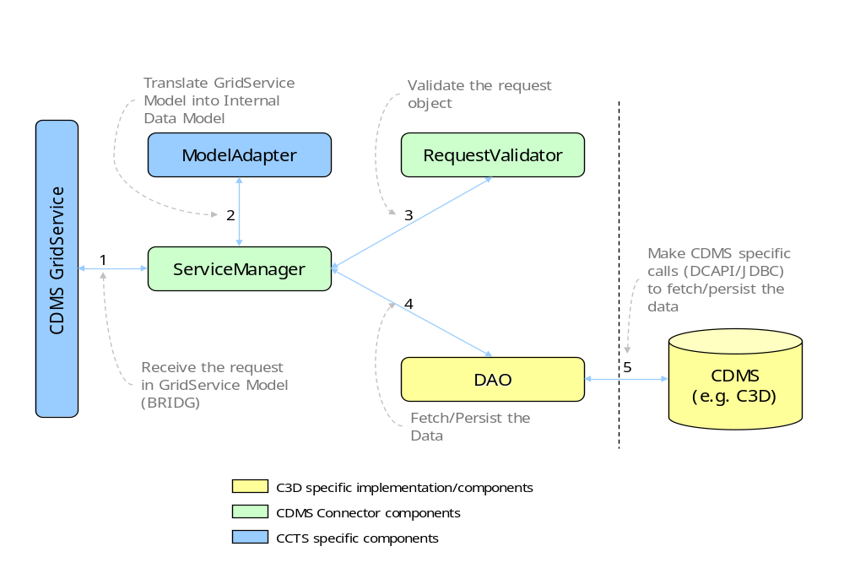
Figure 4 Overall flow of services
The request is received by the grid-service layer and passed on to the corresponding ServiceManager, which then makes calls to the necessary methods to accomplish the task.
- The request is passed on to the corresponding ServiceManager.
- The first job inside ServiceManger is to translate the request from BRIDG Model to the internal data model. A utility method in the ModelAdapter does the task. The request object returned from the ModelAdapter is used elsewhere in the processing.
- The request object is then passed on to the corresponding RequestValidator to validate the request.
- After the request is found to be completely valid, it is sent to the DAO Layer for further processing.
- The DAO then makes CDMS specific calls to store the data. In the case of C3D Java Native (JNI) calls are made to DCAPI dll’s which then interact with the database. The database URL and credentials are read from an external properties file. Also, the various data-fields to be stored in the database can be easily controlled through an xml file. Data returned by the CDMS calls, is processed back through the DAO, out through the ServiceManager and ModelAdpater to the GridService as normal Java messaging.
As the Clinical Connector is a Grid Service, it does not have a user interface of its own. It relies on other external systems to invoke it and provides its output through normal Java messaging services.

Class Diagram
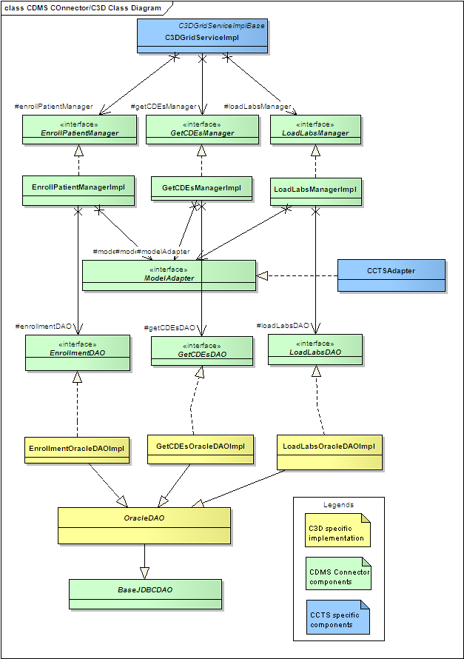
Figure 5 Class Diagram
Appendix A References

Technical Manuals and Articles
- National Cancer Institute. “caCORE SDK 3.2 Programmers Guide”: http://ncicb.nci.nih.gov/infrastructure/cacoresdk
- Java Bean Specification: http://java.sun.com/products/javabeans/docs/spec.html
- Object-Relational Mapping articles and products: http://www.service-architecture.com/object-relational-mapping/
- Java Programming: http://java.sun.com/learning/new2java/index.html
- Javadoc tool: http://java.sun.com/j2se/javadoc/
- Junit: http://junit.sourceforge.net/
- Extensible Markup Language: http://www.w3.org/TR/REC-xml/
- XML Metadata Interchange: http://www.omg.org/technology/documents/formal/xmi.htm
- Silver level compatibility is described here: https://cabig.nci.nih.gov/guidelines_documentation/caBIGCompatGuideRev2_final.pdf

caBIG® Material
- caBIG®: http://cabig.nci.nih.gov/
- caBIG® Compatibility Guidelines: http://cabig.nci.nih.gov/guidelines_documentation

caCORE Material
- caCORE: http://ncicb.nci.nih.gov/NCICB/infrastructure
- caBIO: https://wiki.nci.nih.gov/display/caBIO/caBIO+Wiki+Home+Page
- caDSR: http://ncicb.nci.nih.gov/NCICB/infrastructure/cacore_overview/cadsr
- EVS: http://ncicb.nci.nih.gov/NCICB/infrastructure/cacore_overview/vocabulary
- CSM: https://cabig.nci.nih.gov/tools/CSM
Appendix B Glossary
Term | Definition
{jboss-home} | The base directory where Jboss is installed on the server
API | Application Programming Interface
caBIG® | cancer Biomedical Informatics Grid
caBIO | Cancer Bioinformatics Infrastructure Objects
caCORE | cancer Common Ontologic Representation Environment
cardinality | Cardinality describes the minimum and maximum number of associated objects within a set
CDE | Common Data Element
CDISC | Clinical Data Interchange Standards Consortium
CSM | Common Security Module
CTMS | Clinical Trial Management Systems
CVS | Concurrent Versions System
DAO | Data Access Objects
DAS | Distributed Annotation System
EA | Enterprise Architect
EBI | European Bioinformatics Institute
EVS | Enterprise Vocabulary Services
GULCCC | Georgetown University Lombardi Cancer Center
HIPPA | Health Insurance Portability and Accountability Act
HTTP | Hypertext Transfer Protocol
ISO | International Organization for Standardization
JAAS | Java Authentication and Authorization Service
JAR | Java Archive
Javadoc | Tool for generating API documentation in HTML format from doc comments in source code (http://java.sun.com/j2se/javadoc/)
JBI | Java Business Integration
JDBC | Java Database Connectivity
JET | Java Emitter Templates
JMI | Java Metadata Interface
JSP | JavaServer Pages
JUnit | A simple framework to write repeatable tests (http://junit.sourceforge.net/)
LDAP | Lightweight Directory Access Protocol
LLT | Log Locator Tool
LOINC | Logical Observation Identifier Names and Codes
MedDRA | Medical Dictionary for Regulatory Activities
metadata | Definitional data that provides information about or documentation of other data.
Multiplicity | Multiplicity of an association end indicates the number of objects of the class on that end may be associated with a single object of the class on the other end
NCI | National Cancer Institute
NCICB | National Cancer Institute Center for Bioinformatics
OMG | Object Management Group
ORM | Object Relational Mapping
RDBMS | Relational Database Management System
SDK | Software Development Kit
Semantic connector | A development kit to link model elements to NCICB EVS concepts.
SIG | Special Interest Group
SQL | Structured Query Language
UI | User Interface
UID | User Identification
UML | Unified Modeling Language
UMLS | Unified Medical Language System
UPT | User Provisioning Tool
URL | Uniform Resource Locators
WAR | Web Application Archive
WSDL | Web Services Description Language
XMI | XML Metadata Interchange (http://www.omg.org/technology/documents/formal/xmi.htm) - The main purpose of XMI is to enable easy interchange of metadata between modeling tools (based on the OMG-UML) and metadata repositories (OMG-MOF) in distributed heterogeneous environments
XML | Extensible Markup Language (http://www.w3.org/TR/REC-xml/) - XML is a subset of Standard Generalized Markup Language (SGML). Its goal is to enable generic SGML to be served, received, and processed on the Web in the way that is now possible with HTML. XML has been designed for ease of implementation and for interoperability with both SGML and HTML

Index

Additional Documents, 8
Administration Guide, 8
Installation Guide, 8
Use Cases, 8
Administration Guide, 8
Architecture, 15
n-tier, 16
Common Data Element, 14, 23
DCAPI, 10, 17, 20
Grid, 23
happy.jsp, 12, 13
Installation, 12
Instructions, 12
Prerequisites, 12
Verification, 12
Installation Guide, 8
Requirements, 10
Security, 23
Use Cases, 8
Web Services, 24
WSDL, 24
XML, 24

Silver level compatibility is described here: https://cabig.nci.nih.gov/guidelines_documentation/caBIGCompatGuideRev2_final.pdf

